15 Common Cognitive Distortions

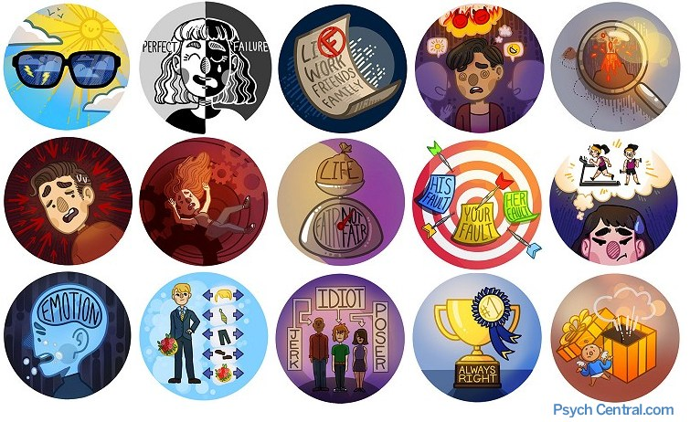
What is a cognitive distortion and why do so many people have them? Cognitive distortions are simply ways that our mind convinces us of something that is not true. These inaccurate thoughts are usually used to reinforce negative thinking or emotions — telling ourselves things that sound rational and accurate, but really only serve to keep us feeling bad about ourselves.
For instance, people might tell themselves, “I always fail when I try to do something new; I therefore fail at everything I try.” This is an example of “black or white” (or polarized) thinking. The person is only seeing things in absolutes — that if they fail at one thing, they must fail at all things. If they added, “I must be a complete loser and failure” to their thinking, that would also be an example of overgeneralization — taking a failure at one specific task and generalizing it as their very self and identity.
Cognitive distortions are at the core of what many cognitive-behavioral and other kinds of therapists try to help a person learn to change in psychotherapy. By learning to correctly identify this kind of “stinkin’ thinkin’,” a person can then answer the negative thinking back and refute it. By refuting the negative thinking repeatedly, it will slowly diminish overtime and be automatically replaced by more rational, balanced thinking.

The Most Common Cognitive Distortions
In 1976, psychologist Aaron Beck first proposed the theory behind cognitive distortions and in the 1980s; David Burns was responsible for popularizing it with common names and examples for the distortions.

1. Filtering
A person engaging in filter, or “mental filtering”, takes the negative details and magnifies those details while filtering out all positive aspects of a situation. For instance, a person may pick out a single, unpleasant detail and dwell on it exclusively so that their vision of reality becomes darkened or distorted. When a cognitive filter is applied, the person sees only the negative and ignores anything positive.

2. Polarized Thinking (or “Black and White” Thinking)
In polarized thinking, things are either “black-or-white” — all or nothing. We have to be perfect or we are a complete and abject failure — there is no middle ground. A person with polarized thinking places people or situations in “either/or” categories, with no shades of gray or allowing for the complexity of most people and most situations. A person with black-and-white thinking sees things only in extremes.

3. Overgeneralization
In this cognitive distortion, a person comes to a general conclusion based on a single incident or a single piece of evidence. If something bad happens just once, they expect it to happen repeatedly. A person may see a single, unpleasant event as part of a never-ending pattern of defeat.
For instance, if a student gets a poor grade on one paper in one semester, they conclude they are a horrible student and should quit school.

4. Jumping to Conclusions
Without individuals saying so, a person who jumps to conclusions knows what another person is feeling and thinking — and exactly why they act the way they do. In particular, a person is able to determine how others are feeling toward the person, as though they could read their mind. Jumping to conclusions can also manifest itself as fortune telling, where a person believes their entire future is pre-ordained (whether it be in school, work or romantic relationships).
For example, a person may conclude that someone is holding a grudge against them, but does not actually bother to find out if they are correct. Another example involving fortune telling is when a person may anticipate that things will turn out badly in their next relationship and will feel convinced that their prediction is already an established fact, so why bother dating.

5. Catastrophizing
When a person engages in catastrophizing, they expect disaster to strike, no matter what. This is also referred to as magnifying and can come out in its opposite behavior, minimizing. In this distortion, a person hears about a problem and uses what if questions (e.g., What if tragedy strikes? What if it happens to me?) to imagine the absolute worst occurring.
For example, a person might exaggerate the importance of insignificant events (such as their mistake or someone else’s achievement). Or they may inappropriately shrink the magnitude of significant events until they appear tiny (for example, a person’s own desirable qualities or someone else’s imperfections).
With practice, you can learn to answer each of these cognitive distortions.

6. Personalization
Personalization is a distortion where a person believes that everything others do or say is some kind of direct, personal reaction to them. They literally take virtually everything personally, even when something is not meant in that way. A person who experiences this kind of thinking will also compare themselves to others, trying to determine who is smarter, better looking, etc.
People engaging in personalization may also see themselves as the cause of some unhealthy external event that they were not responsible for. For example, “We were late to the dinner party and caused everyone to have a terrible time. If I had only pushed my husband to leave on time, this wouldn’t have happened.”

7. Control Fallacies
This distortion involves two different but related beliefs about being in complete control of every situation in a person’s life. In the first, if we feel externally controlled, we see ourselves as a helpless victim of fate. For example, “I can’t help it if the quality of the work is poor; my boss demanded I work overtime on it.”
The fallacy of internal control has us assuming responsibility for the pain and happiness of everyone around us. For example, “Why aren’t you happy? Is it because of something I did?”

8. Fallacy of Fairness
In the fallacy of fairness, a person feels resentful because they think that they know what is fair, but other people will not agree with them. As our parents tell us when we are growing up and something does not go our way, “Life isn’t always fair.” People who go through life applying a measuring ruler against every situation judging its “fairness” will often feel resentful, angry, and even hopelessness because of it. Because life is not fair — things will not always work out in a person’s favor, even when they should.

9. Blaming
When a person engages in blaming, they hold other people responsible for their emotional pain. They may also take the opposite track and instead blame themselves for every problem — even those clearly outside their own control.
For example, “Stop making me feel bad about myself!” Nobody can “make” us feel any particular way — only we have control over our own emotions and emotional reactions.

10. Shoulds
Should statements (“I should pick up after myself more…”) appear as a list of ironclad rules about how every person should behave. People who break the rules make a person following these should statements angry. They also feel guilty when they violate their own rules. A person may often believe they are trying to motivate themselves with “shoulds” and “shouldn’ts”, as if they have to be punished before they can do anything.
For example, “I really should exercise. I shouldn’t be so lazy.” Musts and oughts are also offenders. The emotional consequence is guilt. When a person directs should statements toward others, they often feel anger, frustration and resentment.

11. Emotional Reasoning
The statement can sum up the distortion of emotional reasoning, “If I feel that way, it must be true.” Whatever a person is feeling is believed to be true automatically and unconditionally. If a person feels stupid and boring, then they must be stupid and boring.
Emotions are extremely strong in people, and can overrule our rational thoughts and reasoning. Emotional reasoning is when a person’s emotions take over our thinking entirely, blotting out all rationality and logic. The person who engages in emotional reasoning assumes that their unhealthy emotions reflect the way things really are — “I feel it, therefore it must be true.”

12. Fallacy of Change
In the fallacy of change, a person expects that other people will change to suit them if they just pressure or cajole them enough. A person needs to change people because their hopes for success and happiness seem to depend entirely on them.
This distortion is often found in thinking around relationships. For example, a girlfriend who tries to get her boyfriend to improve his appearance and manners, in the belief that this boyfriend is perfect in every other way and will make them happy if they only changed these few minor things.

13. Global Labeling
In global labeling (also referred to as mislabeling), a person generalizes one or two qualities into a negative global judgment about themselves or another person. This is an extreme form of overgeneralizing. Instead of describing an error in context of a specific situation, a person will attach an unhealthy universal label to themselves or others.
For example, they may say, “I’m a loser” in a situation where they failed at a specific task. When someone else’s behavior rubs a person the wrong way — without bothering to understand any context around why — they may attach an unhealthy label to him, such as “He’s a real jerk.”
Mislabeling involves describing an event with language that is highly colored and emotionally loaded. For example, instead of saying someone drops her children off at daycare every day, a person who is mislabeling might say, “She abandons her children to strangers.”

14. Always Being Right
When a person engages in this distortion, they are continually putting other people on trial to prove that their own opinions and actions are the absolute correct ones. To a person engaging in “always being right,” being wrong is unthinkable — they will go to any length to demonstrate their rightness.
For example, “I don’t care how badly arguing with me makes you feel, I’m going to win this argument no matter what because I’m right.” Being right often is more important than the feelings of others around a person who engages in this cognitive distortion, even loved ones.

15. Heaven’s Reward Fallacy
The final cognitive distortion is the false belief that a person’s sacrifice and self-denial will eventually pay off, as if some global force is keeping score. This is a riff on the fallacy of fairness, because in a fair world, the people who work the hardest will get the largest reward. A person who sacrifices and works hard but does not experience the expected pay off will usually feel bitter when the reward does not come.
References:
Beck, A. T. (1976). Cognitive therapies and emotional disorders. New York: New American Library.
Burns, D. D. (2012). Feeling good: The new mood therapy. New York: New American Library.
Leahy, R.L. (2017). Cognitive Therapy Techniques, Second Edition: A Practitioner’s Guide. New York: Guilford Press.
McKay, M. & Fanning, P. (2016). Self-Esteem: A Proven Program of Cognitive Techniques for Assessing, Improving, and Maintaining Your Self-Esteem. New York: New Harbinger Publications.
Image by PschCentral 2016

